2.5 **Smoke sensor**

This smoke sensor module with MQ2 Smoke sensor have both digital and analog outputs , you also can adjust the sensitivity with the potentiometer.

Gas Sensor(MQ2) module is useful for gas leakage detection (home and industry). It is suitable for detecting H2, LPG, CH4, CO, Alcohol, Smoke or Propane. Due to its high sensitivity and fast response time, measurement can be taken as soon as possible. The sensitivity of the sensor can be adjusted by the potentiometer.

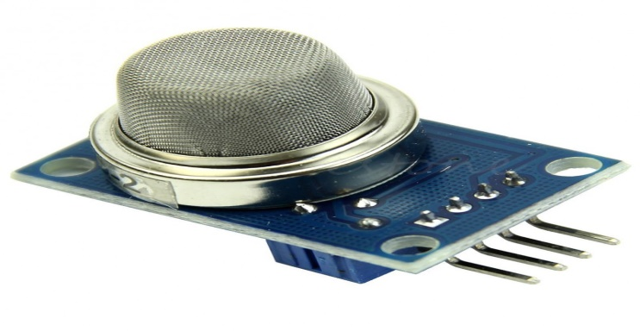

**Figure 2.5 smoke sensor**

**PIN Connection**

* VCC    (5 V)
* GND (ground)
* Aout (Analog output)
* Dout (Digital output

### Features:

* Operating Voltage is +5V
* Can be used to Measure or detect LPG, Alcohol, Propane, Hydrogen, CO and even methane
* Analog output voltage: 0V to 5V
* Digital Output Voltage: 0V or 5V (TTL Logic)
* Preheat duration 20 seconds
* Can be used as a Digital or analog sensor
* The Sensitivity of Digital pin can be varied using the potentiometer

2.5.1 Internal structure of MQ2 Gas Sensor

The sensor is actually enclosed in two layers of fine stainless steel mesh called Anti-explosion network. It ensures that heater element inside the sensor will not cause an explosion, as we are sensing flammable gases.

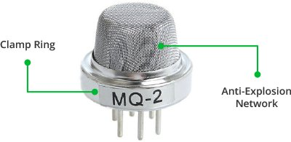

## 2.5.2How does a gas sensor work

When tin dioxide (semiconductor particles) is heated in air at high temperature, oxygen is adsorbed on the surface. In clean air, donor electrons in tin dioxide are attracted toward oxygen which is adsorbed on the surface of the sensing material. This prevents electric current flow.

In the presence of reducing gases, the surface density of adsorbed oxygen decreases as it reacts with the reducing gases. Electrons are then released into the tin dioxide, allowing current to flow freely through the sensor.

### 2.5.3 Selecting between Sensor type and module type

When it comes to measuring or detecting a particular Gas the **MQ series Gas sensors** are the most commonly used ones. These sensors can either be purchased as a module or as just the sensor alone. If you are trying to only detect (not measuring ppm) the presence of a gas then you can buy it as a module since it comes with an op-amp comparator and a digital out pin. But if you planning to measure the ppm of a gas it is recommended to buy the sensor alone (without module).